Application Number | 07/2018/8346/FUL
Address | Meadowcroft Business Park  Pope Lane  Whitestake  Preston  Lancashire  PR4 4BA
Applicant | Messrs TJ Haley MR Bailey
Agent | Mr David Shepherd  20 Collingwood Avenue  St Annes  Lytham St Annes  FY8 2SB
Development | Construction of a new access road (amendment to previous approval 2016/1292/FUL)
Officer Recommendation  Officer Name | Approval with Conditions  Mrs Janice Crook
Date application valid | 22.11.2018
Target Determination Date | 17.01.2019
Extension of Time | 12.02.2019
Location Plan

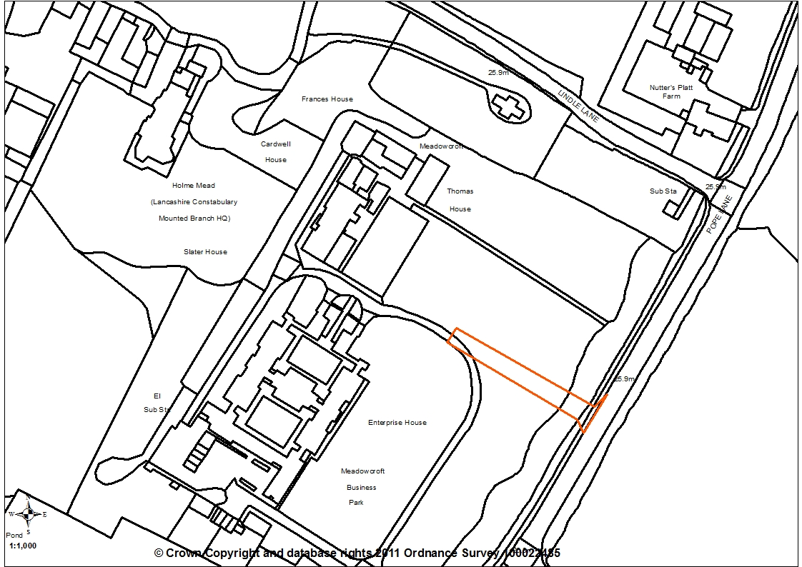

- Report Summary

1.1 This application seeks to regularise the situation with regards to the access road from Pope Lane serving the Meadowcroft Business Park. Members may recall planning application 07/2016/1292/FUL for a new access road which was refused by planning committee in June 2017 but was allowed on appeal. The access road was largely constructed but not in accordance with the approved plans and has not as yet been utilised.

1.2 The site is within the Green Belt and an assessment of the impact the amended access road has on the Green Belt has been carried out and, with reference to the Inspector’s appeal decision, the scheme is considered acceptable and the application is recommended for approval subject to the imposition of conditions.

- Site and Surrounding Area

2.1 The application relates to land fronting Pope Lane in Whitestake and is located to the front of an office development, part of the former Meadowcroft Business Park. The site comprises of a grouping of buildings which currently houses five individual businesses together with an associated car parking area The adjacent site has permission for a residential development of 14 dwellings with access to the Business Park through this development. The surrounding area consists of a mix of single and two storey residential properties to the south, the Lancashire Constabulary Mounted Branch complex to the west, open green belt land to the east and Lindle Lane to the north.

- Planning History

- 07/1986/0350 Change of use of staff house no.2 from residential to office use for Social Services Emergency Duty Team. APV 30/07/1986
- 07/1996/0772 Change of Use From School Residential Block to Accountants Offices (Use Class A2) and Use of Adjacent Tennis Court for Associated Parking. APV 22/01/1997
- 07/1997/0650 Erection of Two and Single Storey Extensions, Formation of Staff Car Park, Erection of Security Fencing to Rear and Installation of 4 No 6 Metre High CCTV Columns. APV 04/02/1998
- 07/1999/0643 Change of use from C2 Residential Institution to mixed use of Offices (B1), Training Centre (C2) and Catering Facilities and formation of car park to rear. APV 24/11/1999
- 07/2012/0695/FUL for the erection of 14 Residential Dwellings following demolition of existing buildings on the adjacent site, APV 15/05/2013.
- 07/2016/0567/VAR for a variation of condition 2 to amend the site layout in respect of the re-location of the site turning head APV 13/10/2016
- 07/2016/1292/FUL Construction of new access road and junction of Meadowcroft Business Park was refused by planning committee on 20/06/2017 on one ground:

“The proposed access road would reduce the openness of the Green Belt and would have an adverse effect on the purposes of including land in the Green Belt, in particular it would not assist in safeguarding the countryside from encroachment. Very special circumstances necessary to justify the development have not been clearly demonstrated. Furthermore, the development would also cause significant harm to the character and appearance of the surrounding area. As such, it would represent inappropriate development in the Green Belt contrary to the National Planning Policy Framework and Policy G1 of the South Ribble Local Plan.”

3.1 The applicant appeal the decision with the Inspector allowing the appeal on 7th February 2018.

- Proposal

4.1 The application is an amendment to the scheme 07/2016/1292/FUL allowed on appeal for the construction of a new access road to serve the offices at the Meadowcroft Business Park. As approved, the access road was to be 3m wide and 66m in length. The access road as built has a footpath either side and is a total of 6.9m wide (including the footpaths) for an overall length of 87m, part of it merging with the existing access road.

4.2 An existing footpath which dissects the grassed area to the front of the site, approximately 87m long by 1.7m wide is to be removed and returned to grass.

- Summary of Publicity

- Neighbouring properties were notified and a site notice posted with no letters of representation being received.

- Summary of Consultations

7.1 County Highways have no objections to the amended access but request that conditions are imposed to ensure that wheel washing facilities are provided for the duration of the development and that the new access should not be utilised until all the highway works within the adopted highway have been constructed in accordance with a scheme to be submitted.

7.2 County Highways also require an informative note be included on the decision notice to advise the applicant that the vehicle access point will need to be constructed under a section 278 agreement and they, as the Highway Authority, reserve the right to provide the highway works within the highway.

7.3 Ecology has no objections on ecology grounds to the proposal.

7.4 Arboriculturist has no objections to the application but comments that avenue planting as identified on 18 1064 PN001 should consist of fastigiated broadleaf deciduous trees a min 12-14 heavy standard planted in accordance with BS 8545 2014. Planting should take place a suitable distance from the proposed road to allow for the trees to mature. All newly planted trees should have a replacement condition attached for replanting on a like for like basis for a minimum of five years.

7.5 Environmental Health had not responded at the time of writing the report. If any comments are received, these will be reported verbally at the committee meeting.

7.6 Hutton Parish Council had not responded at the time of writing the report. If any comments are received, these will be reported verbally at the committee meeting.

- Policy Background

8.1 The National Planning Policy Framework sets out at paragraph 143. That inappropriate development is, by definition, harmful to the Green Belt and should not be approved except in very special circumstances. It requires, when considering any planning application, the local planning authorities should ensure that substantial weight is given to any harm to the Green Belt. ‘Very special circumstances’ will not exist unless the potential harm to the Green Belt by reason of inappropriateness, and any other harm resulting from the proposal, is clearly outweighed by other considerations. At paragraph 145. The NPPF require the LPA to regard the construction of new buildings as inappropriate in the Green Belt but then sets out a number of exceptions to this, such as buildings for agriculture and forestry or the replacement of a building, provided the new building is in the same use and not materially larger than the one it replaces.

8.2 The NPPF, at paragraph 146 sets out that certain other forms of development are also not inappropriate in the Green Belt provided they preserve its openness and do not conflict with the purposes of including land within it. These include engineering operations and the construction of a new access road is such an operation.

8.3 The Rural Development Supplementary Planning Document sets out the Council’s approach to development in rural areas. Chapter D deals with employment and recognises that it is important that employment opportunities exist in rural areas to enable local people to access employment close to where they live and to help avoid excessive levels of commuting to urban areas.

8.4 South Ribble Local Plan Policy G1: Green Belt has a general presumption against inappropriate development and planning permission will not be given for the construction of new buildings unless there are very special circumstances. However, in line with the NPPF, exceptions to this are buildings for agriculture and forestry; provision of appropriate facilities for outdoor sport, outdoor recreation and for cemeteries, as long as it preserves the openness of the Green Belt and does not conflict with the purposes of including land within it; the extension or alteration of a building provided that it does not result in disproportionate additions over and above the size of the original building; the replacement of a building, provided the new building is in the same use and not materially larger than the one it replaces; limited infilling in villages, and limited affordable housing for local community needs under policies set out in the Local Plan; or limited infilling or the partial or complete redevelopment of previously developed sites, whether redundant or in continuing use (excluding temporary buildings), which would not have a greater impact on the openness of the Green Belt and the purpose of including land within it than the existing development. Policy G1 also recognises that there are a number of major developed employment sites within the Green Belt. These sites can be developed within their curtilage. These major developed employment sites should continue to secure jobs and prosperity without further prejudicing the Green Belt. Such development is considered appropriate in the terms of the NPPF.

8.5 At paragraph 10.28 Policy G1 recognises that certain other forms of development are also not inappropriate in the Green Belt provided they preserve the openness of the Green Belt and do not conflict with the purposes of including in in Green belt. These include engineering operations.

- Material Considerations

9.1 Planning History
9.1.2 Members will recall that planning application 07/2016/1292/FUL was refused by planning committee on 20 June 2016 on one ground:
“The proposed access road would reduce the openness of the Green Belt and would have an adverse effect on the purposes of including land in the Green Belt, in particular it would not assist in safeguarding the countryside from encroachment. Very special circumstances necessary to justify the development have not been clearly demonstrated. Furthermore, the development would also cause significant harm to the character and appearance of the surrounding area. As such, it would represent inappropriate development in the Green Belt contrary to the National Planning Policy Framework and Policy G1 of the South Ribble Local Plan.”

9.1.3 The applicant appealed this decision with the Inspector allowing the appeal, having considered the main issues to be:
“Whether the proposal is inappropriate development in the Green Belt for the purposes of the National Planning Policy Framework (the Framework) and the development plan, including the effect on the openness of the Green Belt and the purposes of including land within it, and; the effect on the character and appearance of the area.” The Inspector concluded that the development is not inappropriate development in the Green Belt as it would preserved the openness of the Green Belt and does not conflict with the purposes of including land in Green Belt and also that the development would not harm the character and appearance of the area and would not conflict with Policy G1 of the Local Plan or the NPPF.

9.1.4 A number of conditions were imposed by the Inspector and of relevance is condition 2 which required the development to be carried out in accordance with the approved plan and listed those plans by reference number. Additionally, a further three of the conditions referred back to condition 2. These relevant conditions are as follows:
“2) The development hereby permitted shall be carried out in accordance with the following approved plans: 8859 L00 Rev P1; 8859 B2; TC/P5672/15/150 Rev C; TC/P5672/15/151 Rev C; TC/P5672/15/152 Rev B; TC/P5672/15/153 Rev B; TC/P5672/15/154 Rev B; TC/P5672/15/100 Rev B.
3) Notwithstanding condition 2, no part of the development hereby permitted shall take place until a scheme for the construction of the site access has been submitted to and approved in writing by the local planning authority. The site access and the associated section of access road hereby permitted shall not be brought into use until the development has been constructed and completed in full accordance with the approved plans and the agreed scheme.
4) Notwithstanding condition 2, no part of the development hereby permitted shall take place until a detailed scheme for mitigation tree planting to compensate for the loss of trees to be removed has been submitted to and approved in writing by the local planning authority. The agreed mitigation tree planting measures shall be fully implemented by a suitably qualified person and in accordance with BS8545: 2014. The tree planting shall be implemented in the first planting season following the commencement of the development or such extension of this time as may be agreed in writing by the local planning authority. Any trees which within a period of 5 years from the completion of the development die, or are removed or become significantly damaged or diseased shall be replaced in the next planting season with others of similar size and species, unless the local planning authority gives written consent to any variation.
5) Notwithstanding condition 2, the development hereby approved shall be carried out in accordance with the Arboricultural Development Report by Tree Check Ltd dated February 2017. Before any development hereby permitted takes place, barrier fencing shall be erected around all trees to be retained on the site. The fencing shall be constructed and located in compliance with BS5837:2012. Within the fenced areas; no development, vehicle manoeuvring, storage of materials or plant, or removal or addition of soil may take place including ground disturbance for utilities. The fencing shall not be moved in part or wholly without the written agreement of the local planning authority. The fencing shall remain in place until completion of all development works and removal of site vehicles, machinery, and materials in connection with the development. An inspection programme of the protective fencing shall be established and recorded by a suitably qualified person as part of their overall site monitoring and a copy of the recordings submitted to the local planning authority on completion of the development.”

9.1.5 The access road has been largely completed but it became apparent during the development that its construction was not as per the approved plans and therefore this full planning application has been submitted in order to regularise the situation. Therefore an assessment of the wider access road and footpath is provided below in respect of its impact on the Green Belt location in which it is set.

9.2 Compliance with Green Belt Policy
9.2.1 The proposal constitutes appropriate development in the Green Belt. Works to construct an access road are classed as an engineering operation, which Paragraph 146 of the National Planning Policy Framework advises is not inappropriate development in the Green Belt, provided that it does not conflict with the purposes of including land within the Green Belt and on condition that it preserves openness.

The principle characteristic of the Green Belt is its openness, upon which the proposed development will have a negligible impact. By their very nature, access roads do not introduce visual impairments to the openness of the Green Belt, being low lying and largely absent of structures. Whilst it is noted that the as built access road is wider (6.9m wide) and includes footpaths to either side than that originally allowed on appeal (3m), it remains that the construction of an access road is not inappropriate development in the Green Belt.

9.2.2 Furthermore, having regard to the appeal Inspectors decision, the access road is not considered to be inappropriate in this Green Belt location as it preserves the openness and does not conflict with the purposes of including land within it:
“The section of access road as proposed would only be visible from its junction with Pope Lane, from the adjacent residential development and from within the Business Park itself. The insertion of the junction of the access road within the grass verge when viewed from Pope Lane would not look out of place in a location where a pedestrian footway exists and a sequence of junctions are nearby, including those that serve the current access road, Green Lane and Lindle Lane respectively. The subdivision of the landscaped area which fronts both the residential development and the Business Park would appear coherent as the section of access road proposed would align with the existing section leading to the car park where it adjoins the boundary with the residential development. Furthermore, the access road would assimilate with the surfacing of the current access road, the presence of car parking areas and the backdrop of built form associated with the Business Park and residential development. The proposal would not, therefore, have a harmful effect on the character and appearance of the area”.

9.2.3 Although the as build access road is wider and includes footpaths to either side, it is not considered to have any detrimental impact on the openness of the Green Belt over and above that of the approved access road. As justification, the applicant has indicated that the approved access road was not wide enough for the intended use, stating in the submitted Planning Statement:
“In its currently approved state, it does not allow for adequate passing of vehicles and needs to be slightly wider than approved. As proposed, the road and footway would be circa 6.9m wide typically……… A slightly wider road with footpath would also allow improvements in disabled/wheel chair access to the site/buildings as accessed from Pope Lane with provision of a new footpath. This would be better than the historic footpath that goes through the grassed area at the front of the site (which is approximately 87 metres by 1.7 metres). This original path would be removed, and the area returned to grass which would be visually better as it would green-up the area…..”

9.2.4 Additionally, as part of this current proposal, the Planning Statement indicates that the historic footpath that goes through the grassed area at the front of the site which is approximately 87 metres by 1.7 metres is to be removed and the area returned to grass to the benefit of the visual amenity of the area and pedestrian safety.

9.3 Trees and Ecology
9.3.1 The proposal has no additional impact on trees in the area and the Council’s Arboriculturist has confirmed there are no arboricultural objections to the proposal. However, the Arboriculturist comments that avenue planting as identified on drawing 18 1064 PN001 should consist of fastigiated broadleaf deciduous trees a minimum 12-14 heavy standard planted in accordance with BS 8545 2014. Planting should take place a suitable distance from the proposed road to allow for the trees to mature. All newly planted trees should have a replacement condition attached for replanting on a like for like basis for a minimum of five years and this can be included on the decision notice.

9.3.2 The Council’s Ecological Advisors have no objections to this application on ecology grounds.

- Conclusion

10.1 Although the access road has not been constructed in accordance with the approved plans, it is considered that its present form does not have any additional detrimental impact on the openness of the Green Belt and the purpose of including land within it. Additionally it has the benefit of providing a safer pedestrian route for users of the Meadowcroft Business Park and removes a secondary pathway with that area being return to grass. The scheme is therefore considered acceptable and the application is recommended for approval subject to the imposition of conditions.

RECOMMENDATION:

Approval with Conditions.

RECOMMENDED CONDITIONS:

1. The development, hereby permitted, shall be carried out in accordance with the submitted approved plans Dwg 18 1064 PN001 Rev B New Road Access
REASON: For the avoidance of doubt and to ensure a satisfactory standard of development

2. The tree planting scheme identified on Dwg 18 1064 PN001 Rev B shall be implemented in the first planting season following approval of the development. The trees shall consist of fastigiated broadleaf deciduous trees a minimum 12-14 heavy standard and shall be planted by a competent, professional person and in accordance with BS8545: 2014. Any trees which within a period of 5 years from the completion of the development die, or are removed or become significantly damaged or diseased shall be replaced in the next planting season with others of similar size and species, unless the Local Planning Authority gives written consent to any variation.
REASON: In the interests of the amenity and appearance of the area in accordance with Policy 17 in the Central Lancashire Core Strategy and Policy G13 in the South Ribble Local Plan 2012-2026

3. No part of the new access shall be utilised until all the highway works within the adopted highway have been constructed in accordance with a scheme that shall be submitted to and approved by the Local Planning Authority in consultation with the Highway Authority as part of an appropriate legal agreement, under the Highways Act 1980.
REASON: In order to satisfy the Local Planning Authority and Highway Authority that the final details of the highway scheme/works are acceptable.

4. External lighting associated with the development shall be directional and designed to avoid excessive light spill and shall not illuminate bat roosting opportunities within the site or trees and hedgerows in the area. The principles of relevant guidance should be followed (e.g. the Bat Conservation Trust and Institution of Lighting Engineers guidance Bats and Lighting in the UK, 2009).
REASON: To ensure that adequate provision is made for these protected species in accordance with Policy 22 in the Central Lancashire Core Strategy and Policy G16 in the South Ribble Local Plan 2012-2026

RELEVANT POLICY

G1 Green Belt

Informative Note:

The applicant is advised that the vehicle access point, will need to be constructed under a section 278 agreement. The Highway Authority hereby reserves the right to provide the highway works within the highway associated with this proposal. Provision of the highway works includes design, procurement of the work by contract and supervision of the works. The applicant is advised to contact Lancashire County Council before works begin on site. Further information and advice can be found at www.lancashire.gov.uk

